Part 2 Design Guide

**GUI Design**

**Jump If Zero (JZ) Instruction:**

**Jump if Not Equal (JNE) Instruction:**

**Jump if Condition (JCC) Instruction:**

**Unconditional Jump to Address (JMA) Instruction:**

**Jump and Save Return Address JSR Instruction:**

**Return From Sub-Routine (RFS) Instruction:**



**Subtract One and Branch (SOB) Instruction:**

**Jump Greater Than or Equal to (JGE) Instruction:**

**Add Immediate to Register (AIR) Instruction:**

**Add Memory to Register (AMR) Instruction:**

**Subtract Memory from Register (SMR) Instruction:**

**Subtract Immediate from Register (SIR) Instruction:**

**Multiply Register by Register (MLT) Instruction:**

**Divide Register by Register (DVD) Instruction:**

**Test Equality of Register with Register (TRR) Instruction:**

**Logical And of Register with Register (AND) Instruction:**

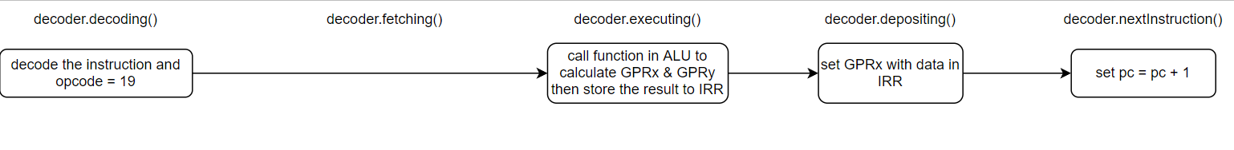

**Logical Or of Register with Register (ORR) Instruction:**

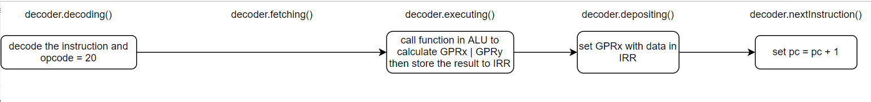

**Logical Not of Register with Register (NOT) Instruction:**



**Shift Register by Count (SRC) Instruction:**

**Rotate Register by Count (RRC) Instruction:**

**Program 1 Flowchart (Turn Sideways)**

**Class Diagram:**

Please refer to the file “Class-Diagram-Version2” that will be included in our Submission Folder.